Radio-Led Education: Fostering Awareness of Unique and Natural Resources in Bicol Region among Elementary and High School Students in Selected Schools of Tabaco City, Albay, Philippines
Antonino B. Mendoza, Jr. (corresponding author)
Bicol University Tabaco, Tabaco City, Albay, 4511, Philippines
E-mail: ajbmendoza@bicol-u.edu.ph

Maria Luisa U, Tango
Bicol University Tabaco, Tabaco City, Albay, 4511, Philippines

Michael C. Borejon
Bicol University Tabaco, Tabaco City, Albay, 4511, Philippines

Mariel B. Bernadas
Bicol University Tabaco, Tabaco City, Albay, 4511, Philippines

Aileen B. Rances
Bicol University Tabaco, Tabaco City, Albay, 4511, Philippines

Received: Dec. 10, 2023 Accepted: Jan. 12, 2024 Published: February 1, 2024
doi:10.5296/jse.v14i1.21569 URL: https://doi.org/10.5296/jse.v14i1.21569

Abstract
This study examined the effectiveness of radio-based instruction in enhancing students' knowledge of Bicol's unique and natural resources across different educational levels. The research encompasses elementary, junior high school (JHS), and senior high school (SHS) students, evaluating their pretest and posttest scores in response to radio programs on various environmental topics. The radio intervention significantly improved knowledge levels among elementary students, particularly in the tilapia topic, showcasing a 70.31% gain. For JHS students, notable progress was observed, with a remarkable 123.08% gain in invertebrates. SHS students also exhibited enhanced knowledge, achieving a 50.85% gain, emphasizing the positive impact of radio-based instruction on environmental education. While acknowledging contextual challenges and evolving technology trends, this study underscores the vital role of radio in fostering environmental awareness and positive conservation behaviors among students in the Bicol Region. The results suggest that radio programs are potent tools for promoting environmental education and empowering students to contribute actively to conservation efforts.
Keywords: radio-based instruction, environmental education, KADUNUNG Bicol, natural gems

1. Introduction
The Republic Act 9512, otherwise known as the National Environmental Awareness and Education Act of 2008, seeks to promote environmental consciousness and responsibility among the Filipino people by institutionalizing environmental education programs in schools, businesses, and communities. This law aims to enhance public understanding of environmental issues, foster sustainable practices, and encourage active participation in environmental conservation efforts.
In response, the Department of Education (DepEd) issued Order No. 52, Series of 2011, aimed at implementing the integration of environmental education (EE) within the curriculum of both public and private schools. The directive underscores the imperative of cultivating environmental awareness among students and teachers, emphasizing the significance of environmental protection and elucidating the ramifications of climate change. Consequently, numerous initiatives were launched to enhance EE efforts, particularly in elementary and secondary educational institutions. However, within the Philippine basic education framework, EE is not recognized as a standalone learning domain but as an integrated subject within the core curriculum. Challenges stemming from the integration process, including inadequate teacher training, a shortage of instructional materials, and a discernible lack of student interest in these interdisciplinary topics, have been identified.
Bicol Region has diverse flora and fauna, some of which can only be found in the region, like the Sinarapan (M. luzonensis). Others are abundantly found or utilized, like Pili (C. ovatum), scallops (Family: Pectinidae), fermented or fresh kuyog (Family: Siganidae), mud crabs, tunas, and others (Mendoza et al., 2021a; Mendoza et al., 2021b; Mendoza et al., 2023).
Radio-based instruction has been utilized as an alternative mode of teaching and learning. In the Philippines, radio-based education has a long history; it gained prominence during the pre- and post-war periods and was effective for educational outreach (Enriquez, 2008). One significant milestone in radio-based education in the Philippines was during World War II when radio broadcasts were utilized for instructional purposes. During the Japanese occupation (1942-1945), radio became a crucial medium for disseminating educational content, including lessons in science, mathematics, and language (Enriquez, 2008). In the mid-70s, this was also used to implement health and nutrition improvement programs especially directed toward parents' better food choices and health care (Cooke and Romweber, 1977).
The advent of COVID-19, however, has disrupted the normal education system globally and has resulted in the utilization of several teaching and learning modalities. This motivated the implementation a dedicated radio program geared toward enhancing environmental awareness among selected students in the Tabaco City Schools Division.
This study determined the effect of radio-based instruction on knowledge of the unique and natural resources of the Bicol to elementary and high school students in selected schools in Tabaco City, Albay, Philippines. Specifically, this study determined the changes in elementary and high school student's knowledge of Bicol's unique and natural resources before and after listening to the radio program and compared the changes in knowledge of Bicol's unique and natural resources of students between year levels.
2. Methodology
2.1Research Design
The study employed an impact evaluation research design. The study used a pre-test-post-test method to examine the changes in students' knowledge about the Bicol Region's unique and natural resources due to the radio program intervention
  - Participants/Respondents
A total of 314 students from Bantayan (Upland), San Lorenzo (Urban), and San Miguel (Island) elementary and high schools in Tabaco City, Albay, participated in the study. The chosen levels per area setting were fifth (5th) grade in elementary, eighth (8th) grade in junior high school, and eleventh (11th) grade in senior high school with a general academic strand (GAS). Respondents in Bantayan included 45 fifth-grade students, 40 eighth-grade students, and 40 eleventh-grade students. In San Lorenzo, 33 elementary students, 39 junior high students, and 37 senior high students took part, while 30 students from each level did respond in San Miguel.
2.3 Instrument
A pre-test was given before the intervention to examine the students' prior knowledge of the fifteen (15) topics. The same test questionnaires were given to the students after the intervention. The elementary level received five (5) multiple-choice test questions, while the junior and senior high school levels received ten (10) items of the same test questions. Most test questions focused on students’ stock knowledge and understanding of basic and general knowledge about the topics discussed during the radio program. The questions for both levels focused on the species' biology, ecology, and systematics, including technical topics such as the status and aquatic processes for the high school level. The researchers derived the test questions from the findings of the Bicol University Tabaco Campus (BUTC) study, as well as from the materials of the resource speakers in radio programming and some from the published article.
2.4 Data gathering procedures
The researchers obtained permission to conduct the study from Tabaco City's Schools Division Superintendent (SDS), school principals, and participants' parents. Memorandums of Understanding (MOU) were secured for the partners and participating schools to strengthen cooperation among the involved parties. The student's parents were consulted through several assemblies to introduce the program and inform them of its purpose. After the approval of the MOA, pre-tests were given a week before the program topic discussion on air, and post-tests were given after a week.
  - Radio Programming
The radio program was conducted for 1 hour daily from Monday to Friday. Each topic was divided into 5 subtopics, a topic covered in a week where a subtopic is discussed daily. Discussing a single topic per week was done to unburden students from excessive learning load. BUTC faculty members and experts from various agencies were invited to discuss their research and paper publication. BFAR, DENR, and others to convey with listeners, including the respondents and their parents, as well as ordinary listeners. Participation of listeners, particularly the students, was encouraged during the live broadcast program's question-and-answer to monitor their being tuned in to the program. A replay of the broadcast on the KADUNUNG Facebook page was carried out for those unable to watch the live broadcast of the program.
  - Data Analysis
The students' pre-and post-test scores were analyzed using descriptive statistics such as frequency counts and percentages. The percentage gain was also determined to examine the increase in knowledge and awareness of the students in every topic.
3. Result and discussion
The average score for the pretest among elementary students ranged from 1.63 to 2.69. The former mean score was for the topic of Tilapia, while the latter mean score was computed for the topic of Crabs. Among the radio program topics discussed, tilapia, milkfish, and shrimp posted the lowest average pretest scores, whereas butanding (whale shark), siganids, and tuna posted the highest mean pretest scores. This means that compared to marine species (butanding, siganids, and tuna), elementary students' knowledge of cultured fish species (tilapia, milkfish, and shrimp) is comparatively low. This indicated that students’ knowledge about aquaculture species is lower than their knowledge about those species of fish captured from the wild.
However, due to the radio intervention, elementary students' scores in all topics had increased. Specifically, the topic tilapia increased from an average pretest score of 1.63 to an average posttest score of 2.48, representing a 70.31% percent gain, the highest in the topics discussed in the radio program. Meanwhile, the topics butanding, siganids, and tuna posted relatively modest percent gains of 18.85%, 22.41%, and 23.18%, respectively (Figure 1).
In general, elementary students' knowledge of the topics about the natural fishery resources of Bicol improved by 42.62%, from an average pre-test score of 2.24 to an average post-test score of 2.84. The results were consistent with the study of Gosselin and Hurst (2018), which showed an average increase of 30% in elementary students' knowledge due to an intervention in environmental education. This suggests that radio programs as a modality for public environmental education can increase knowledge by one-half.
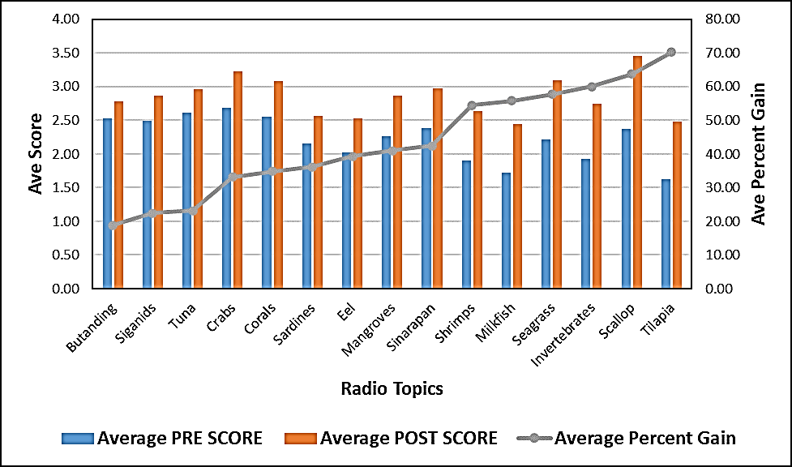
Figure 1. Comparison of pre-score, post-score, and percent gain among elementary students in each topic
Based on the results of this study, junior high school students, like elementary school students, lacked sufficient knowledge about unique and natural resources before the radio intervention. The discussion done on air on the topics of shrimp, invertebrates, and sardines posted the lowest average pre-test scores, with 2.90, 3.27, and 3.63 points respectively out of a possible 10 points. While butanding (whale shark), crabs, and sinarapan (smallest commercial fish) posted the highest average pretest scores of 5.37, 5.08, and 4.75, respectively (figure 2). The average post-test scores increased after listening to the radio program for the topics. It is worth noting that the topics on invertebrates registered a gain of 123.08%. This means that junior high school students made significant progress in the mentioned topics. Overall, Junior High School students improved by 60% from an average pre-test score of 4.13 to an average post-test score of 5.49. Although some research indicates that there are some disadvantages to using radio as a mode of instruction, such as limited signals from telecommunications, radio, and televisions in the island and upland areas than in urban areas (Mendoza et. al., 2023; Ho and Thukral, 2009), as well as educational radio is mainly a one-way medium with little or no interactivity (Elliot and Lashley 2017). Furthermore, as modern technology advances, students are increasingly focused on social media rather than listening to the radio. With this, the motivation of the students to listen was low except for those elementary students who were accompanied by their parents. This study found that the capability of the radio as a tool for environmental education is influenced by a variety of contextual factors such as electricity, intention, and end-user motivation (Elliot and Lashley 2017). On the contrary, Olakulehin (2016) argued that to transmit knowledge, ideas, skills, and attitudes, instructional radio must be used in teaching to supplement, clarify, vitalize, emphasize, instruct, and enhance learning.
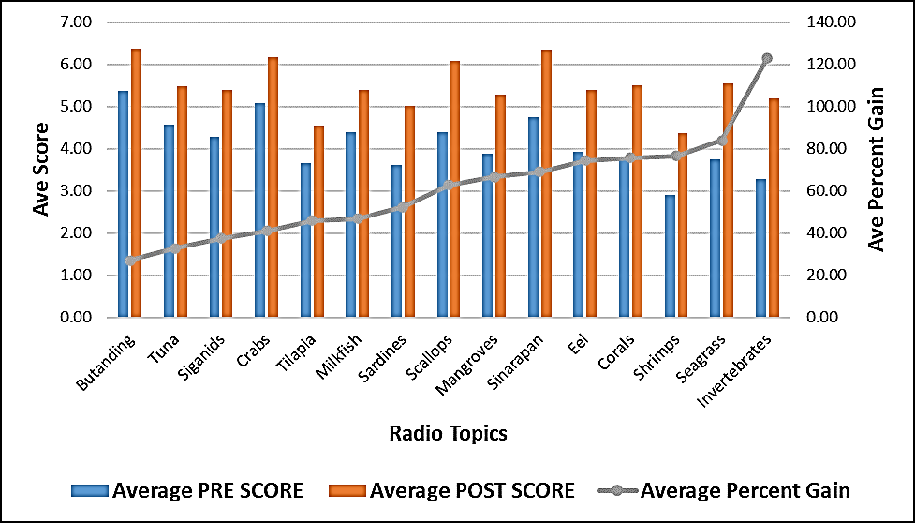
Figure 2. Comparison of pre-score, post-score, and percent gain among JHS students in each topic
Similar to elementary and junior high school students, senior high school students had insufficient prior knowledge of Bicol's unique and natural resources. The average pretest score in the topic’s shrimps, tilapia, and sardines is low, with average pretest scores of 3.60, 3.68, and 3.69 out of 10. The topics with the highest average pretest scores were butanding (whale shark), scallops, and tuna, with average pretest scores of 5.48, 5.15, and 5.10, respectively. After listening to the radio, the posttest results of senior high students showed an increase in all topics. Regarding percent gain, the topic corals have the highest with 81.86% followed by the topic seagrass with 76.69%. Overall, SHS had improved by 50.85% from an average pre-test score of 4.46 to an average post-test score of 5.76. The slight improvement in SHS knowledge and awareness regarding the natural resources in the Bicol region is because, at this stage, the students have more stock knowledge from their previous learnings. As observed, JHS and SHS have higher pre-test scores by around 100% than elementary pupils. As such, the room for improvement might have been constrained compared to elementary students who started with lower baseline knowledge. On the other hand, SHS students may have been less engaged or motivated by the radio-based instruction compared to their younger counterparts. As mentioned above, the obsessiveness of the young generation with technology gadgets can influence the level of engagement and, consequently, the degree of knowledge assimilation. Wu and Siu (2020) discussed the impact of excessive mobile phone use on adolescents' lives, including academic performance, mental health, and overall well-being. The addiction greatly affected the performance in education and well-being.
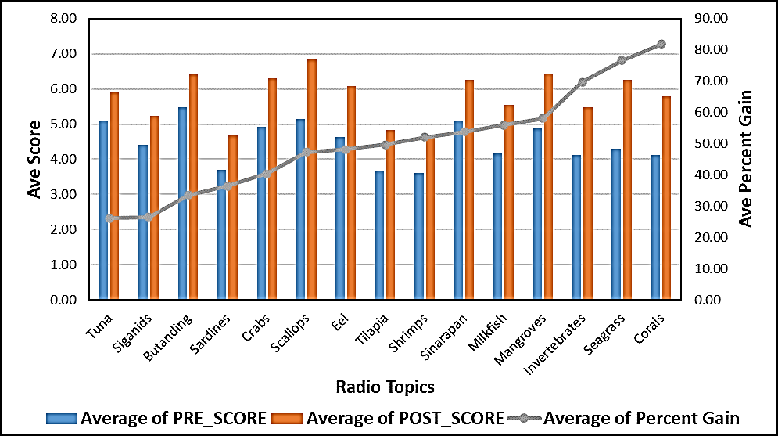
Figure 3. Comparison of pre-score, post-score, and percent gain among SHS students in each topic
The use of radio as a means of instruction shows an increase in the student's learning about the unique and natural resources of Bicol, which is the same as the study of Elliot and Lashley in 2017. This leads to a high level of knowledge and awareness of the students about their local resources and environment. These suggest a higher degree of awareness and positive behavior from the students for conserving and protecting the environment. Awareness or knowledge about the environment and its resources is critical in conservation and management (Mendoza et al., 2023).
4. Conclusion
The findings of this study unequivocally underscore the efficacy of radio-based instructions in augmenting students' awareness and understanding of the unique and natural resources within their locality, particularly in the Bicol Region. The demonstrated increase in knowledge levels represents a pivotal step toward fostering a heightened sense of environmental consciousness among students. This heightened awareness, poised to support sustainability interventions, has the transformative potential to mobilize students as an active force for constructive engagement in conservation and protection initiatives. Recognizing students as potential catalysts for positive environmental change, the study illuminates the pivotal role of radio-based instructions in cultivating a generation that is informed and empowered to contribute meaningfully to the ongoing efforts to safeguard and conserve the environment.
5. Recommendation
This paper recommends a continuous implementation of environmental education, which should be integrated into the elementary and secondary curricula. Moreover, there is a need for the KADUNUNG learning materials to be institutionalized to raise environmental awareness of the Bicolano youths.
Acknowledgment: This project was funded by the Commission on Higher Education (CHED). We would also like to thank the schools participating in this project: San Miguel Elementary and National High School, San Lorenzo Elementary and National High School, and Bantayan Elementary and National High School. In addition, the LGU Tabaco and SDO Tabaco.
Declaration of interest: The authors declare that they have no competing interests.
Ethics declaration: The authors declared that ethical approval was not required for this study as it did not involve using sensitive or identifiable personal data and did not pose any risk to the participants. However, consent was secured from the Department of Education, Tabaco City Division, to distribute and collect pre- and post-test instruments for elementary and high school students.
References
Cooke, T.M. and Romweber, S.T. (1977). Radio advertising techniques and nutrition education: A summary of a field experiment in the Philippines and Nicaragua. Manoff International.
Elliot, V. and Lashley, L. (2017). The effectiveness of Interactive Radio Instruction (IRI)within selected primary schools in region number four (4). Social Science Learning Education Journal, 2(8), 22-37. https://doi.org/10.15520/sslej.v2i9.38
Enriquez, E.L. (2008). Appropriation of colonial broadcasting: A history of early radio in the Philippines, 1922-1946. UP Press.
Gosselin, D.C. and Macklem-Hurst, J.L. (2002). Pre-/post-knowledge assessment of an earth science course for elementary/middle school education majors. Journal of Geoscience Education, 50(2), 169-175. https://doi.org/10.5408/1089-9995-50.2.169
Ho, J. and Thukral, H. (2009). Tuned in to student success: Assessing the impact of interactive radio instruction for the hardest-to-reach. Journal of Education for International Development, 4(2), pp.34-51.
Imbong, R.A.D. (2021). On Transistor Radios and Authoritarianism: The Politics of Radio-Broadcasted Distance Learning. Techne: Research in Philosophy & Technology, 25(2). https://doi.org/10.5840/techne2021423137
Mendoza Jr, A. B., Bernadas, M. B., Rances, A. B., Borejon, M. C., Tango, M. L. U., & Bradecina, R. G. (2023). Knowledge and awareness on the fishery resources of elementary and high school students. Aquademia, 7(1), ep23002. https://doi.org/10.30935/aquademia/13118
Mendoza Jr., A. B., Borejon, M. C., & B. Bista, J. K. (2021(a)). Status of Coral Reefs in Lagonoy Gulf, Eastern Bicol, Philippines with Emphasis on Marine Protected Areas. Asian Journal of Fisheries and Aquatic Research, 15(6), 123-129. https://doi.org/10.9734/ajfar/2021/v15i630357
Mendoza, A.B., P. M. Nieves, M. C. Borejon. (2021(b)). Factors Linking Declining Reef Health Ecosystem to Poverty in Lagonoy Gulf, Eastern Bicol, Philippines. Journal of Social Science Studies, 8(2), 135-147. https://doi.org/10.5296/jsss.v8i2.18548
Olakulehin, F.K. (2016). Impact of Instructional Radio Delivery Mode on Academic Achievement of Distance Learning Students in Computer Science. US-China Education Review, 6(12), -688-698. https://doi.org/10.17265/2161-6248/2016.12.002
Wu, J. and Siu, A.C. (2020). Problematic mobile phone use by Hong Kong adolescents. Frontiers in Psychology, 11, 551-804. https://doi.org/10.3389/fpsyg.2020.551804

